Select the correct Logical OR operator

Начало формы

or

|

||

OR

Конец формы

What does the statement if (abc==1) do?

Начало формы

Execute branch when variable abc can be set to 1

Execute branch when variable abc equal to 1

Loop branch till variable abc equal to 1

Конец формы

What does the operator ‘typeof’ used for?

Начало формы

to obtain reference to type constructor

to get name of type

to check is object type the same as type of referenced object

Конец формы

The statement while (3==3) is an example of:

Начало формы

Once branch execution

Infinity loop organization

wrong statement

Конец формы

Select the correct function declaration expression

var function a(){}

var b = function(){}

var c = new Function()

(function d(){})()

Select the correct increment operator

Начало формы

+variable

++variable

variable+

variable++

Конец формы

What are the data types in JavaScript?

Начало формы

float

undefined

number

int

Integer

object

Конец формы

What is the result of next code snippet:

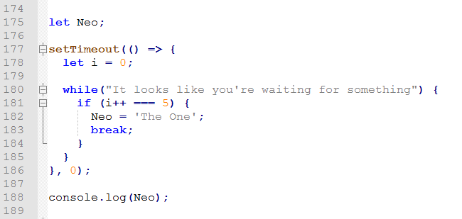

Конец формы

"The One"

0

null

undefined

Select the correct Logical AND operator

Начало формы

and

&

&&

AND

Конец формы

What is function declaration statement?

Начало формы

var a = function (){};

function b(){}

var c = new Function();

(function d(){})();

Конец формы

If the string test contains the value "The eagle has landed", what would be the value of test.length?

Начало формы

23

22

21

20

Конец формы

What are the data types in JavaScript?

Начало формы

float

undefined

number

int

Integer

object

Конец формы

What does the switch statement do?

Начало формы

Switch boolean state

Switch control flow between cases

Make this referenced to context within switch statement

Конец формы

What is the result of next code snippet:

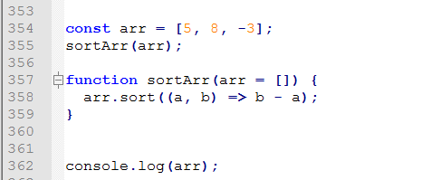

Начало формы

[]

[8, 5 -3]

[-3, 5, 8]

[5, 8, -3]

Конец формы

Select the correct way of creating array

Начало формы

var arr = new Array;

var arr = Array;

var arr = Array(10);

var arr = [];

var arr = [1, new String()];

var arr = new Array('10', 10);

var arr = Array(10, '10');

Конец формы

Select the correct operator of strict equality

Начало формы

==

===

EQ

equ

Конец формы

How can you add a comment in a JavaScript?

Начало формы

; comment

# comment

// comment

/ comment /

/* comment */

/** comment **/

/+ comment +/

Конец формы

Select the correct way of using of conditional operator

Начало формы

var a = b : c ? d;

var a = b ? c : d;

var a = b := c | d;

var a = (b ! c : d);

Конец формы

How to check if variable ’b’ is number type?

Начало формы

typeof b === Number

typeof(b) === "number"

b instanceof Number

typeof(b) === 'int'

typeof b === int

Конец формы

If the string test contains the value "The eagle has landed", which of these statements would return the word ‘eagle’?

Начало формы

test.split(' ')[1]

test.slice(4, 8)

test.slice(4).slice(0, -11)

test.substr(4, 9)

Конец формы

Select a correct way to create an Object

Начало формы

var object = new Object();

var object = {};

var object = Object;

var object = new {};

var object = Object.createObject();

var object = Object.create();

Конец формы

Which type of JavaScript loop checks the condition at the end of the loop?

Начало формы

while (a == 0) do {}

do {} while (a == 0)

for (var a = 0; a < b; ++a) {}

Конец формы

Which of the following objects cannot be used with the new keyword?

Начало формы

new Object;

new {};

new Array;

new [];

new Function;

new function(){};

new Number;

new 20;

new String;

new "str";

Конец формы

After executing the JavaScript statement a=(new Array(10)).toString(), what's the value of ‘a’?

Начало формы

“10”

",,,,,,,,,"

“”

Конец формы

If the statement var abc = 2 appears in a function, which scope does this variable belong to?

Начало формы

global

local

private

Конец формы